**Permutation And Combination:**

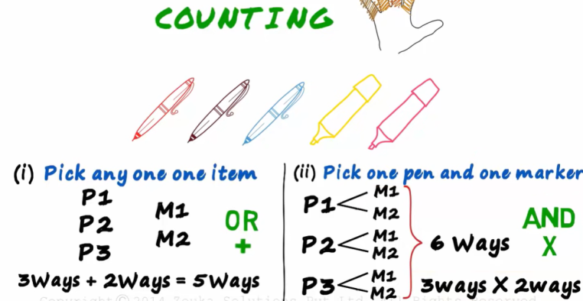 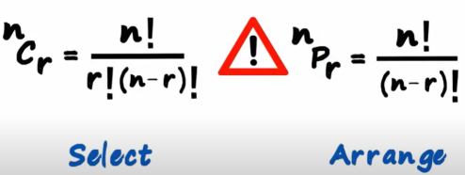

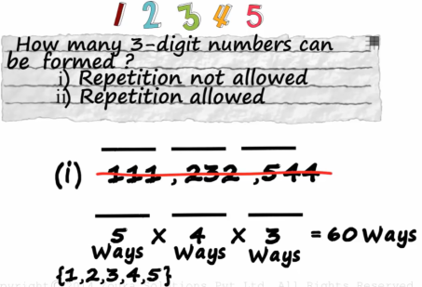 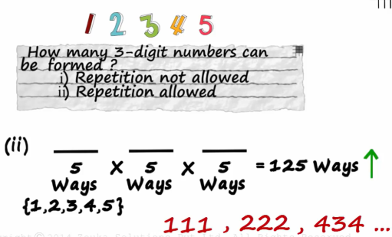

Repetition not allowed Repetition allowed

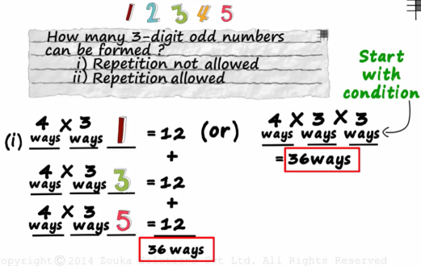 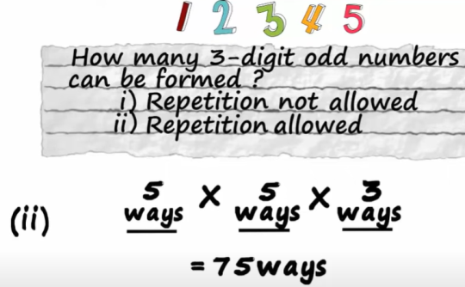

Arranging with a condition = odd Arranging with a condition, repetition allowed

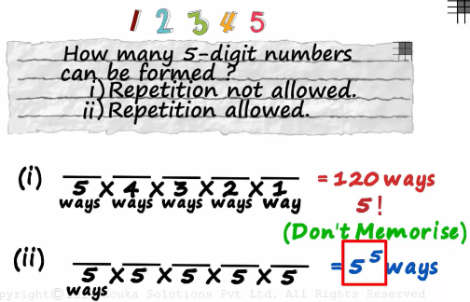

**n!** for **repetition not allowed** and **nn** for **repetition allowed.**

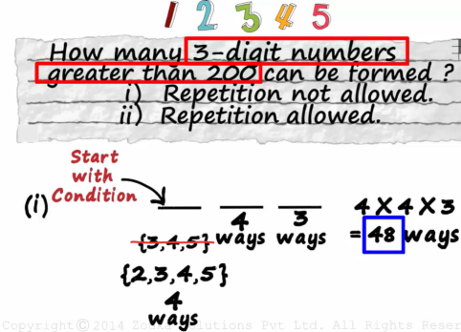 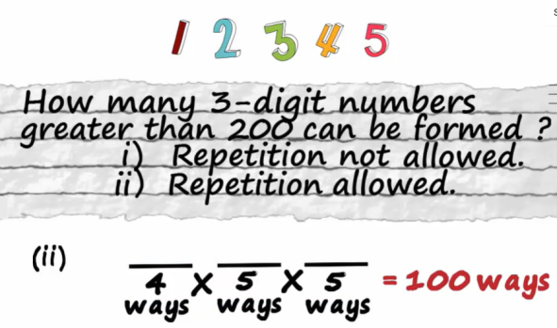

Condition Without Condition

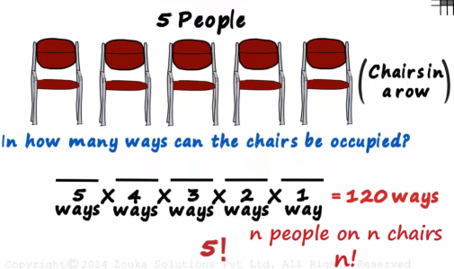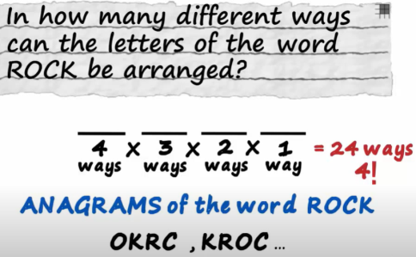

Anagrams = arrangement = permutation = n!

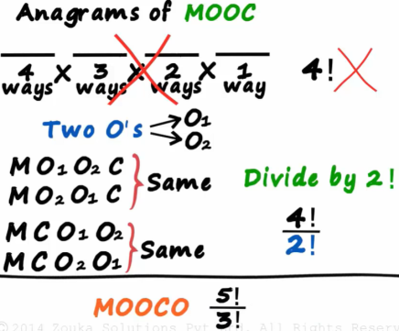 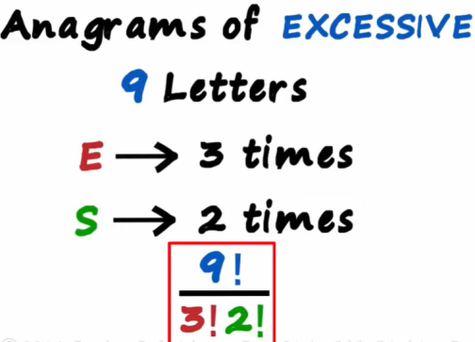

Repeated items arrangement

**General Rules:**

* Whenever we have been given a condition, **always start with the condition**.
* *If repetition is allowed, we don’t have to start with the condition.*
* If repeated items are to be arranged, divide it by the no. if items that are repeated. Coz if in above MOOC eg, O is repeated twice, that means O can be arranged in 2! ways and hence the words will have 2! Redundancy. Hence, answer = 4!/2!

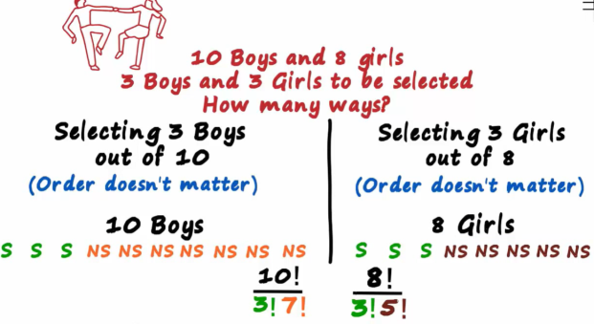

Since S, S and S are similar and all 7 NS are similar 🡺 same prob as Anagrams (coz selecting 3 boys B1 B2 B3 is same as B2 B3 B1 and B3 B2 B1 etc. and hence division by 3! And which is similar as NS1 NS2….. hence /7!)

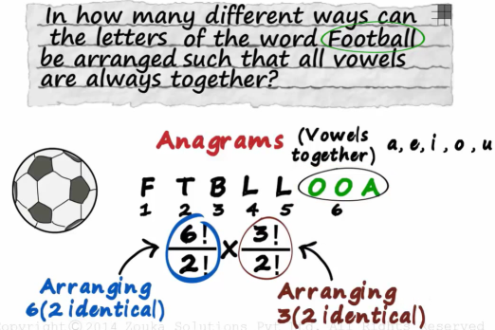

6!/2! (since L is repeated twice) and since we are considering OOA as 1 letter (arranging it will be 3!/2!, 2 coz OO is repeated)

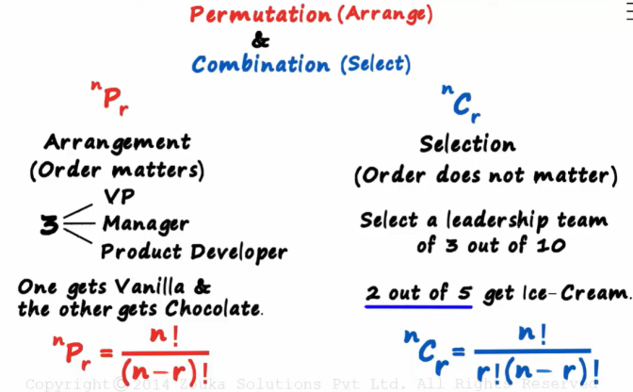

Here, in both cases repetition is not allowed.

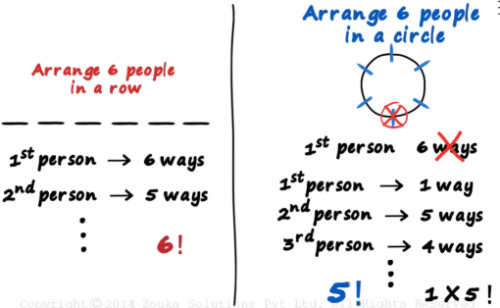

For a circular arrangement, for the 1st person every seat is similar and hence 1st person can be seated in only 1 way.

**Permutation:**

* We have to **arrange**the items
* We choose on the basis of **‘OR’ = ‘+’.**
* **Order matters**. For most of the examples, order only matters for the selected items and not for the items which are not in the answer.

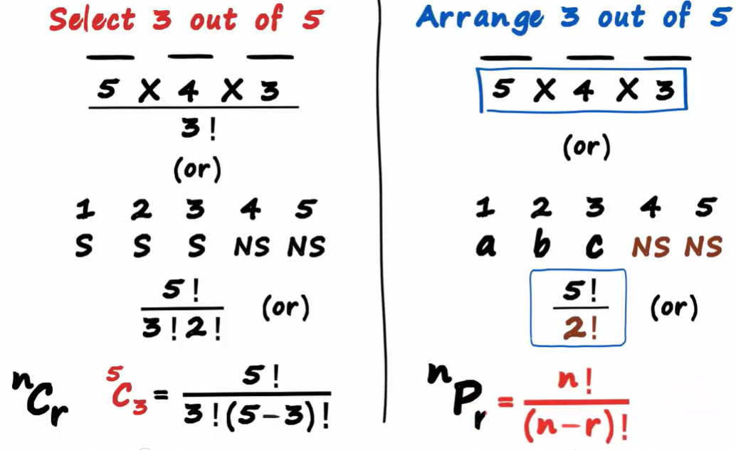

**Combination:**

* We have to **select**the items
* We choose on the basis of **‘AND = ‘*’.**
* **Order doesn’t matter**and hence we divide the answer by similar items as in anagrams or the eg. below.

